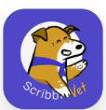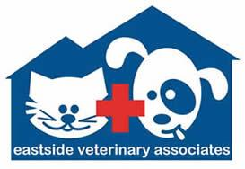
SCRIBBLEVET CONSENT AND RELEASE
Our veterinary services utilize ScribbleVet, a tool from Kairo Care, Inc., which records your pet's appointments for improved clinical documentation. We need your consent to proceed with the recording. By signing this agreement:
1. Appointment Recording: You agree that your vet appointments may be recorded. If you don’t want to be recorded, let us know.
2. Usage Rights: You grant us permission to share these recordings, and any other materials you choose to provide, for the purpose of improved clinical documentation.
3. Age Confirmation & Understanding: You affirm that you are at least eighteen years old, and that you understand and accept the terms in this agreement.
We are committed to providing the best care for your pet in a manner comfortable for both of you.
Date: ________________________________________
Signature: ________________________________________

Printed Name: _____________________________________

