Safety and Liability Information

Please read each statement carefully and sign below:
The dog park can be a fun place to socialize and exercise your dog, but it can also be a dangerous place. The safety of the park completely depends on dog owners using the park responsibly and being attentive to their dog’s body language.
By using the park, you are assuming a risk. You are fully responsible for any injuries or damage caused by your dog. Celtic Creatures Veterinary Clinic is not responsible for any incidences that occur in the park and is not liable from damages or injuries that may happen in the park.
The park is not for all dogs.

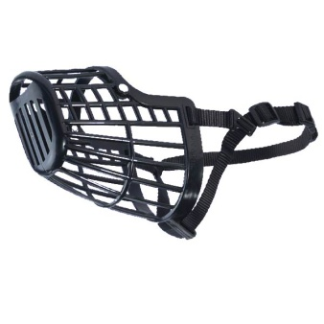
If your dog has attacked or bitten a human or other animal, provoked dog fights or exhibited other aggressive behaviors, the park is not a place for your dog.

Any dog that may pose the slightest risk of biting, should
Wear a basket muzzle. This will allow the dog to pant, exercise
and become socialized, but will prevent the dog from biting.
These can be purchased at the United Farmers Co-op on Keltic Drive.

Dogs that jump up on other people should be leashed.
They could knock someone down and cause an injury.

I , hereby state that I have read and understand the above safety recommendations.

I , hereby state that my dog has never bitten another person or animal and is not dangerous or aggressive. If your dog has bitten, then it must wear a basket muzzle at all times while in the park.

I , hereby promise to always keep a basket muzzle on my dog if it shows signs of aggression or cannot be trusted not to bite or attack another dog or human.

I , take full responsibility for the actions of my dog and assume all liability for any damages my dog (s) may cause while in the park. In the event of any property damage or bodily injury incidents, I agree to hold Celtic Creatures Vet Clinic harmless and release Celtic Creatures Vet Clinic from being named and held responsible.

Signed, Date:

Printed name:

 | Celtic Dog Park
 |  | Membership Form 2024
Membership to the Celtic Dog Park Society is $40+tax for your first dog
and $10+tax for every dog after that. Membership expires Dec. 31, 2024.
 | Irresponsible dog owners and knowingly aggressive dogs
 |  | are NOT permitted to use the park.
Full Name:
Mailing address:
Telephone: |  |  |  | Email:
Vehicle information
Liscense plate: Model: Color:
Canine Information
Dog Name: |  |  |  | Breed(s):
Age: |  | Sex: |  | Color:
Vaccinations UTD: |  | Yes No |  | Veterinarian:
Dog Name: |  |  |  | Breed(s):
Age: |  | Sex: |  | Color:
Vaccinations UTD: |  | Yes No |  | Veterinarian:
Dog Name: |  |  |  | Breed(s):
Age: |  | Sex: |  | Color:
Vaccinations UTD: |  | Yes No |  | Veterinarian:
By signing this form and becoming a member of the Celtic Dog Park you confirm that you have read,
understand and agree to adhere to the rules of the Celtic Dog Park. You will respect the grounds and
become a proactive member of the dog park community. In the event of any property damage or bodily
Injury incidents, you agree to hold Celtic Creatures Vet Clinic harmless and release.
Celtic Creatures Vet Clinic from being named and held responsible
Your membership expires Dec 31, 2024

Signed, Date:

